**A2We Generating a grouped frequency distribution from raw data using SPSS**

Raw data

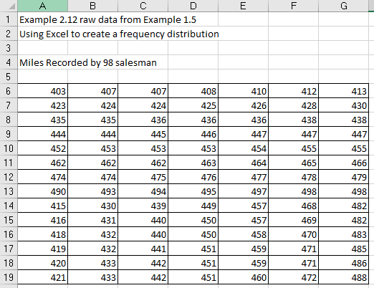

Figure 1

Result

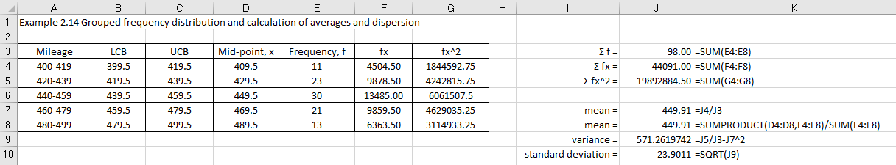

Figure 2

Step 1 Enter data into SPSS

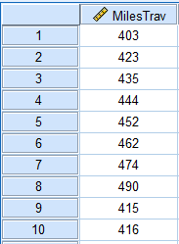

Figure 3

Select 2 Transform data using Visual Binning

Select Transform > Visual Binning

Transfer MilesTrav into the Variables to Bin box

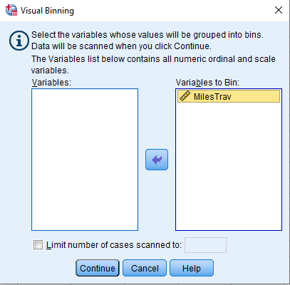

Figure 4

Click Continue

This gives you the Visual Binning dialog box.

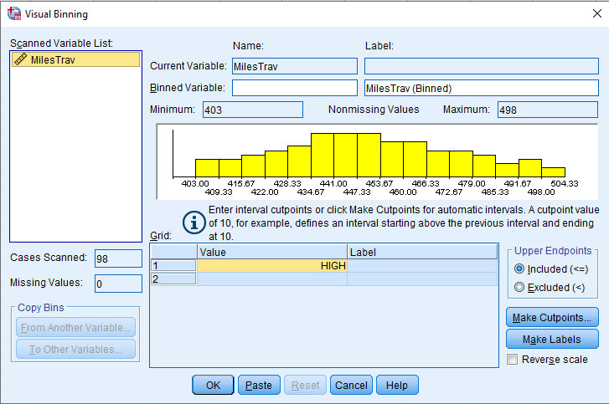

Figure 5

Type MilesTav_binned in the Binned Variable box

Type Miles travelled by 98 salesman (binned) in the Label box

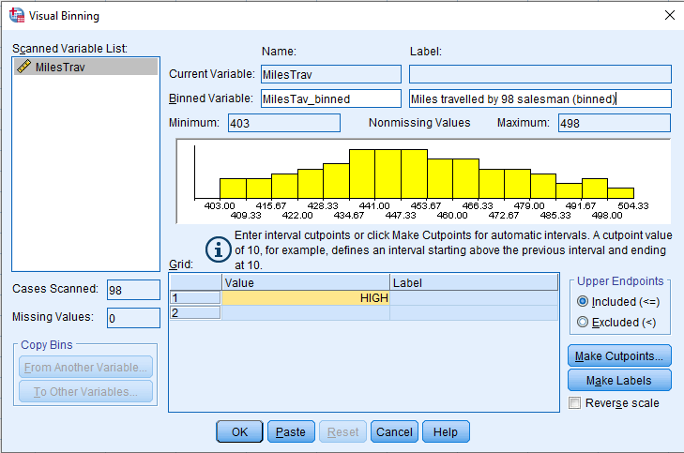

Figure 6

SPSS has already provided you with one cutpoint, HIGH. You provide the others.

* Put the cursor in the row below high and enter a new cutpoint. I entered 400. Hit Return.
* Move the cursor to the bottom row of the grid, enter another new cutpoint. I entered 500. Hit Return.
* Enter other values 420, 440, 460, 480, 500.
* Enter labels

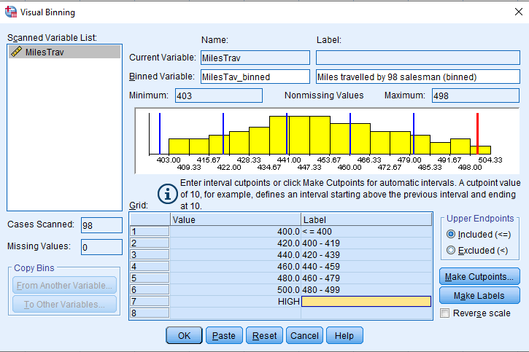

Figure 7

Now I decide that I want the first interval not to include the score of 400, the second interval not the score of 420, and so on. I click the Excluded button. SPSS warns me that the automatically generated labels are no longer correct. I delete those labels (highlight them, hit delete) and click “Make Labels” again.

Finally satisfied with the binning, I click OK.

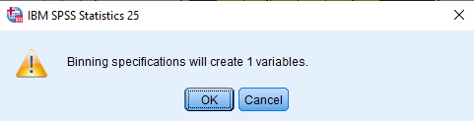

Figure 8

This will create a new variable within your SPSS data file.

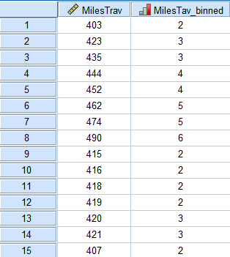

Figure 9

Step 2 Analyse this data variable 

Creating the grouped frequency table

Select Analyze > Descriptive Statistics > Frequencies

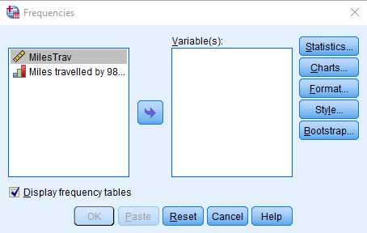

Figure 10

Transfer  into the Variable(s) box

Now create the histogram

Click on Charts

Choose Histograms

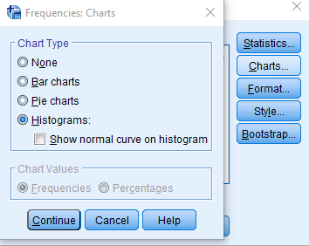

Figure 11

Click Continue

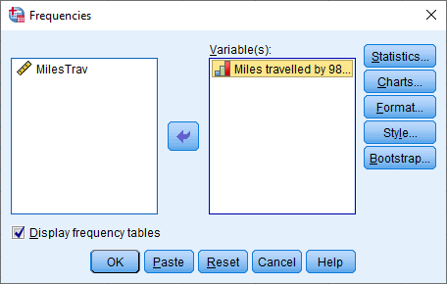

Figure 12

Click OK

SPSS output

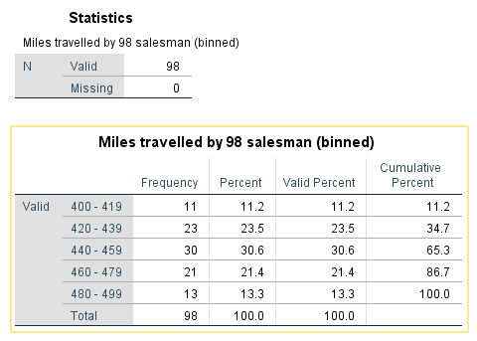

Figure 13

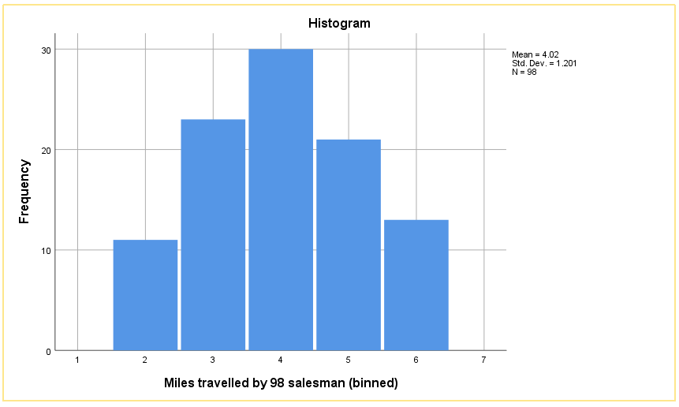

Figure 14

Double click on the graph to edit in SPSS

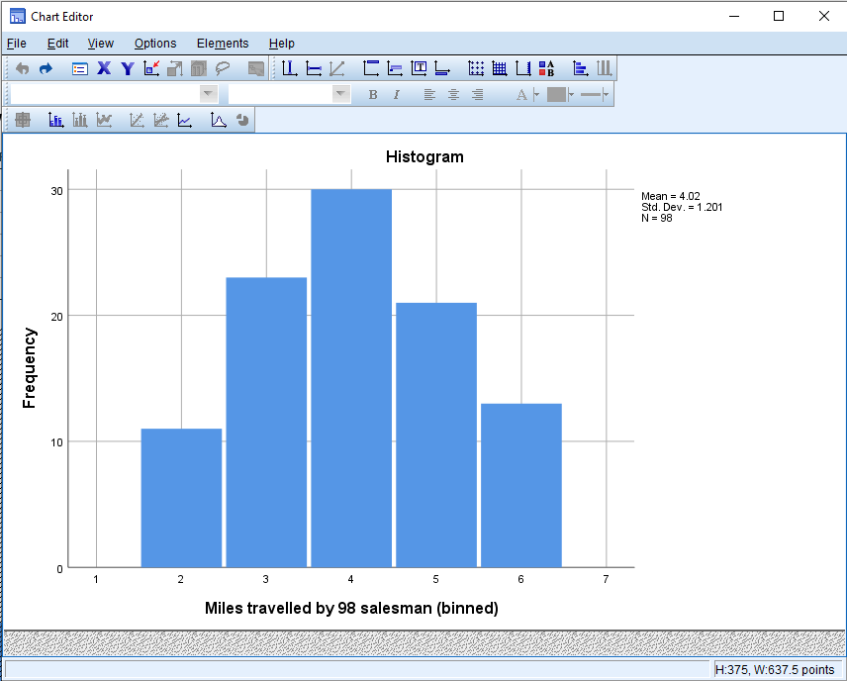

Figure 15

Double click on horizontal axis numbers.



Figure 16

This will open the Properties menu

Switch to Labels and Ticks and switch off Display labels, Click on Apply, Click on Close

Remove the legend, Click on Options > Hide Legend

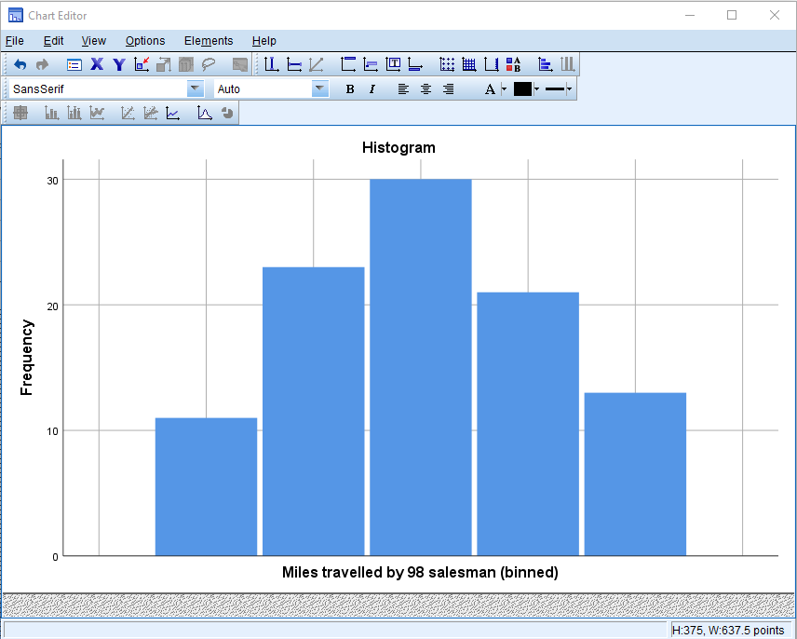

Figure 17

Click on File > Close

Finally, save the SPSS output file

The grouped frequency distribution would then be:

|  |  |
| --- | --- |
| Class | Frequency |
| 400 – 419 | 11 |
| 420 – 439 | 23 |
| 440 – 459 | 30 |
| 460 – 479 | 21 |
| 480 - 499 | 13 |

The histogram would then be

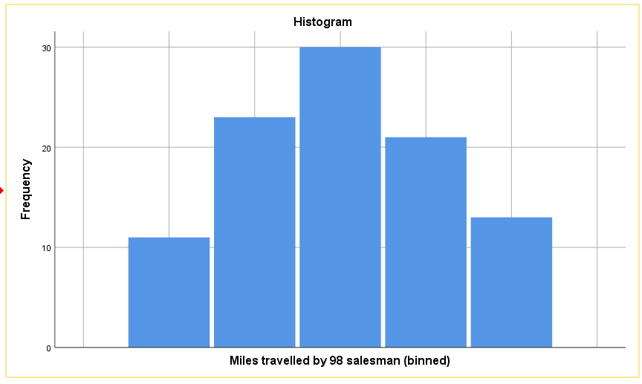

Figure 18